An 'A' in math

User Rating: / 2
PoorBest
Bottom of Form
Written by Nicole Scott
Wednesday, 07 December 2011 16:23
Nicole Scott, Site Coordinator at Ginnings Elementary in the Denton Independent School District, writes about how a student struggling in math has overcome his obstacles with the help of a tutor.
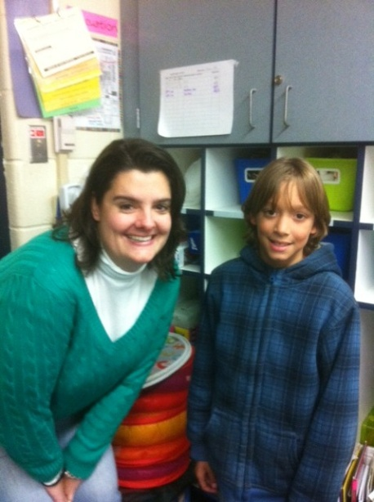Cole is a student in the Communities In Schools of North Texas 21st Century Community Learning Center after school program. He started attending the program in August. After speaking to his mother about some behavior issues he was having, she brought to my attention that Cole was struggling with his math work. His grade was not up to the standards she has for Cole and I let her know that Cole would start going right away with our wonderful tutor, Ms. Macaulay, for some extra help in math.
At first Cole did not like this idea. He was not happy to have to leave his after school room every day to go with Ms. Macaulay to work on his math workbook. He would try to come up with creative excuses as to why he couldn't go to tutoring that day and sometimes he just flat out told her he didn't want to go and this was not helping him. We did not let him get out of tutoring and Ms. Macaulay has been consistently working with Cole for about 2 months now.
When report cards came out, I was anxious to see Cole's math grade. I was so pleased to see that it had gone from a C to an A, and I am so proud of the progress Cole is making. He now understands how helpful tutoring has been and will continue to be. His mom was so happy when she received his grades, and she let me know how thankful she was for Communities In Schools and Ms. Macaulay helping Cole with math.
In the short amount of time I have had to get to know Cole I have seen so many positive changes. His behavior has improved so much and I have not had to talk to him or his mom about it. I have also seen a boost in his confidence, as well as his grades. I could tell he was proud of himself for earning an A in math for the second 6 weeks. He is doing so well in the afterschool program, and I can't wait to see more great improvements from Cole!

